COMPUTER PROGRAMMING

LAB – 1

1. Write a program which will take 2 integer numbers as input from user and it will print output after performing addition, subtraction, multiplication, division and modulus operations.

Print each output in different line and give a tab between operation name and value calculated.

Source Code:

#include <stdio.h>

int main()

{

int num1, num2, sum, sub, mul, divi, mod;

printf("Enter the first number: ");

scanf("%d", &num1);

printf("Enter the second number: ");

scanf("%d", &num2);

sum = num1+num2;

printf("Addition: %d\n", sum);

sub = num1-num2;

printf("Subraction: %d\n", sub);

mul = num1*num2;

printf("Multiplication: %d\n", mul);

divi = num1/num2;

printf("Division: %d\n", divi);

mod = num1%num2;

printf("Remainder: %d\n", mod);

return 0;

}

Output:

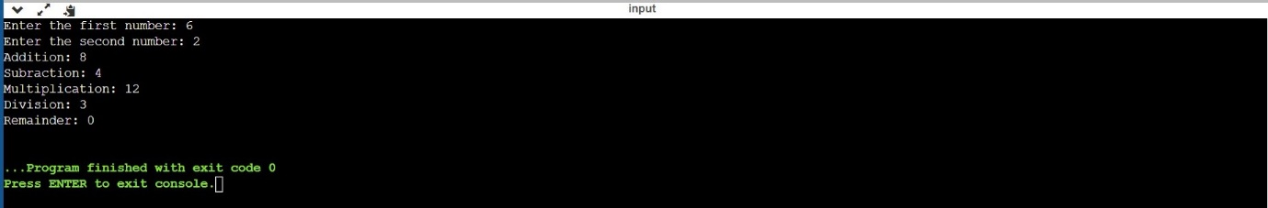

2. Repeat the above program with float numbers.

Source Code:

#include <stdio.h>

int main()

{

float num1, num2, sum, sub, mul, divi, mod;

printf("Enter the first number: ");

scanf("%f", &num1);

printf("Enter the second number: ");

scanf("%f", &num2);

sum = num1+num2;

printf("Addition: %f\n", sum);

sub = num1-num2;

printf("Subraction: %f\n", sub);

mul = num1*num2;

printf("Multiplication: %f\n", mul);

divi = num1/num2;

printf("Division: %f\n", divi);

mod = num1%num2;

printf("Remainder: %f\n", mod);

return 0;

}

Output:

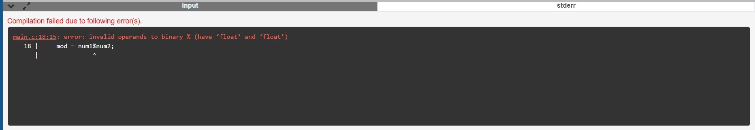

Observation:

The error is because the modulus operator % cannot apply to float or double. It's meant to get the remainder when integer type x is divided by y. It does not have any meaning when you use it with float or double.

3. Write a program to take principle, rate and time from user and print the simple interest as output

Source Code:

#include <stdio.h>

int main()

{

int principle, rate, tim, simple_interest;

printf("Enter the principle: ");

scanf("%d", &principle);

printf("Enter the rate: ");

scanf("%d", &rate);

printf("Enter the tim: ");

scanf("%d", &tim);

simple_interest=((principle*rate*tim)/100);

printf("The simple interest is %d\n", simple_interest);

return 0;

}

Output:

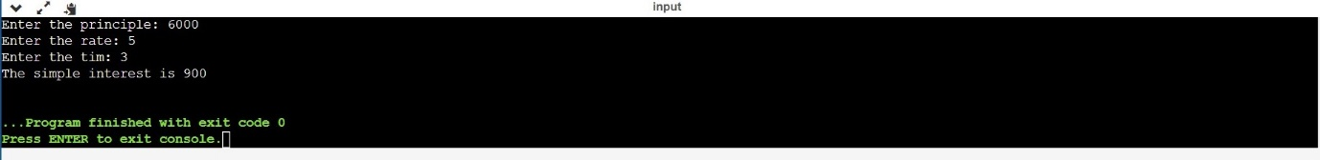

4. Take an integer from user and print square of it.

Source Code:

#include <stdio.h>

int main()

{

int num,sq_num;

printf("Enter the number: ");

scanf("%d", &num);

sq_num = num * num;

printf("The square of the entered number is %d", sq_num);

return 0;

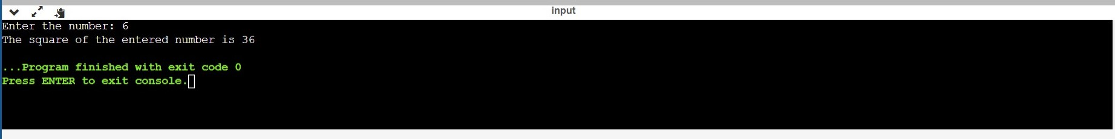Output:

5. Take one float number and one integer from user and multiply and divide integer with float. Write down your observation. Try vice-versa also.

Source Code:

#include <stdio.h>

int main()

{

int num1; float num2;

printf("Enter the first number: ");

scanf("%d", &num1);

printf("\nEnter the second number: ");

scanf("%f", &num2);

printf("Multiplication = %f\n", num1*num2);

printf("Division = %f", num1/num2);

return 0;

}

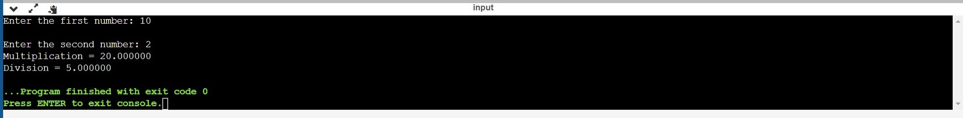Output: